EXERCISE-4
Writing Basic SQL SELECT Statements1. The following statement executes successfully.
Identify the Errors
SELECT employee_id, last_name
sal*12 ANNUAL SALARY
FROM employees;
Queries
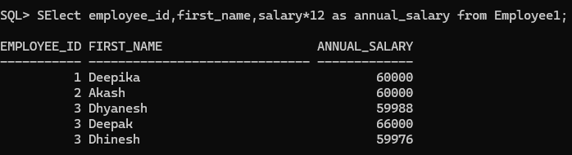

2. Show the structure of departments the table. Select all the data from it.
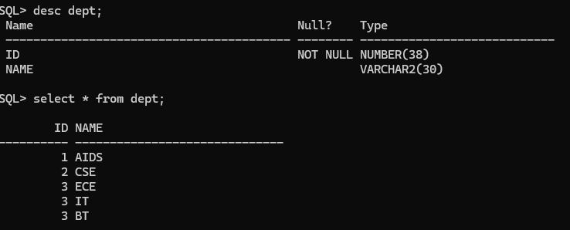
3. Create a query to display the first name, job code, hire date, and employee number for each employee, with employee number appearing first.
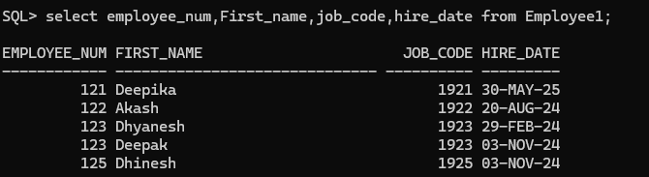
4. Provide an alias STARTDATE for the hire date.
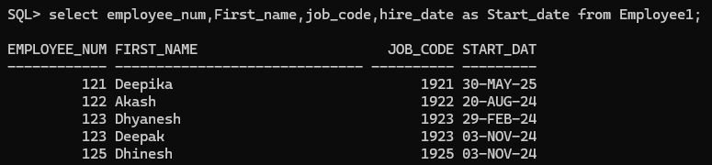
5. Create a query to display unique job codes from the employee table.

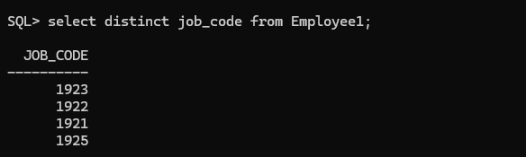
6. Display the last name concatenated with the job ID , separated by a comma and space, and name the column EMPLOYEE and TITLE.
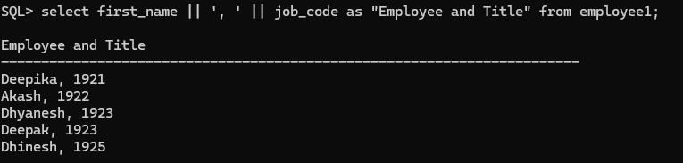
7. Create a query to display all the data from the employees table. Separate each column by a comma. Name the column THE_OUTPUT.
